Instrumental Analysis and Structure Determination of Organic Compounds in Nagoya University

Tarou MEIDAI*¹, John D. SMITH², Xiao-lang LEE³, Jirou CHIKUSA⁴, Benkichi YAGOTO⁵
(¹Technical Center of Nagoya Univ.; ²Research Center for Material Science, Nagoya Univ.; ³Graduate School of Engineering, Nagoya Univ.; ⁴Graduate School of Bioagricaltural Sciences, Nagoya Univ.; ⁵Graduate School of Pharmaceutical Sciences, Nagoya City Univ.)
*Presenter: m-tarou@nagoya-u.jp

Keywords (Within 5 words): Instrumental analysis, Structure determination, NMR, MS

1. Introduction
Technical Center of Nagoya University possesses a shared Instrumentation Facility for all of Nagoya University to analyze molecular structures of organic compounds using nuclear magnetic resonance (NMR) spectrometers, mass (MS) spectrometers, elemental analyzers, and spectrophotoscopic analysis equipment. Here we introduce our utilization system of this facility…………..
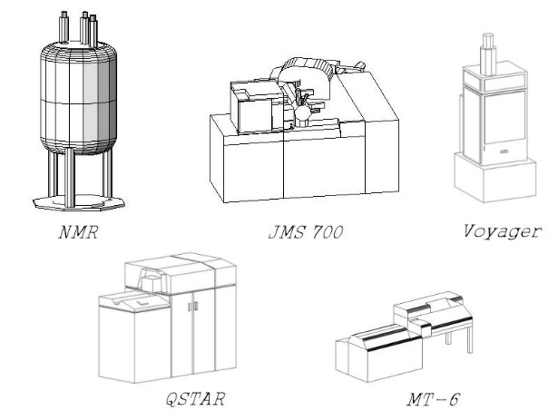
2. Utilization System of Instrumentation Facility
In Technical Center of Nagoya University, services of NMR¹⁾, MS^{2,3)}, element analysis⁴⁾, and so on are provided to users including teaching faculty, researchers, and students through maintenance of these measurement instruments, lectures on measurement methods, consultations for specific measurements, and entrusted measurement (Figure 1)………….
Figure 1. NMR, MS (JMS 700, QSTAR, Voyager) and element analysis (MT-6).

This is a template.
Please refer to “GUIDELINE”
described in Next Page to prepare your manuscript.

References
1) Noguchi, H. Hirokawa books, 2002, NMR for The User. 2) Tamba, T. Kagakudojin, 1995, Current Mass Spectrometry –Application for Biochemistry & Medicine-. 3) Sandoval, C. A.; Ohkuma, T.; Muñiz, K.; Noyori, R. J. Am. Chem. Soc. 2003, 125, 13490–13503. 4) Uchiyama, H. et al. Igakuhyoronsha, 2008, Valuable Methods for Organic Microanalysis.

GUIDELINE FOR PREPARING YOUR MANUSCRIPT
Note: We may change the layout of manuscript by permission of the author.
- DOCUMENT SIZE: A4
Top margin, bottom margin, left side margin, and right side margin must be 20 mm.
Do not enter in header and footer.
- NUMBER of PAGES: 2 or 4 pages only. 1 or 3 pages are not available for convenience of bookbinding.
- TITLE (Word Style “Times or Times New Roman”, Bold, 14 pt, Justify): The title should clearly and concisely reflect the content of the presentation.
- AUTHOR NAME (Word Style “Times or Times New Roman”, 12 pt, Justify): First name and surname of the authors. Do not use only initials. Please write not only the presenter (corresponding author) but also all members who have made substantial contributions to this work. The presenter must be designated with asterisks to whom correspondence should be addressed.
- AUTHOR AFFILIATION (Word Style “Times or Times New Roman”, 11 pt, Justify, Put the affiliations in parentheses): The affiliation should be the institution where the work was conducted.
- AUTHOR MAIL ADDRESS (Word Style “Times or Times New Roman”, 11 pt, Centering): Please describe the mail address of the presenter (corresponding author) under AUTHOR AFFILIATION.
- CHAPTER HEAD SUCH AS “Introduction”, “Result and Discussion”, “Conclusion” and “Acknowledgements” (Word Style “Times or Times New Roman”, Bold, 11 pt).
- TEXT (Word Style “Times or Times New Roman”, 11 pt).
- CITATION IN TEXT: The citation should be placed before any punctuation using a superscript character.
- REFERENCES (Word Style “Times or Times New Roman”, bold, 10 pt)
TEXT IN REFERENCES (Word Style “Times or Times New Roman”, 10 pt): References are placed at the end of the manuscript. Examples of the recommended format are described below.
Example for Journals: Sandoval, C. A.; Ohkuma, T.; Muñiz, K.; Noyori, R. J. Am. Chem. Soc. 2003, 125, 13490–13503.
(Authors, Journal name, Publication year, Volume and Pages.)
Example for Books: Parson W. W. Springer-Verlag Berlin Heidelberg, 2007, Modern Optical Spectroscopy With Examples from Biophysics and Biochemistry.
(Authors, Publisher, Publication year and Book title.)
If a reference has many authors, you are able to write only the first name listed, followed by “et al.”
- FIGURE (Word Style “Times or Times New Roman”, bold, 10 pt)
FIGURE LEGEND (Word Style “Times or Times New Roman”, 10 pt): Figure legends should be described under the figure. The manuscript is printed with monochrome. Do not use the color elements.

